1. 
2. Sometimes multiple threads may need to access some **modified shared resource**. For example, when downloading a file, each thread may need to report the no of bytes it has downloaded to the shared object. With this object, we can keep track of entire download process and report to a user.   
   So multiple threads access the same object and if one of them changes its value, we can run into a situation called **Race Condition.**
3. Following are the possible problems that may occur when multiple threads try to modify shared resource.
4. **Race Condition:**
   1. When multiple threads try to modify same data, it may result in wrong result or app may crash. 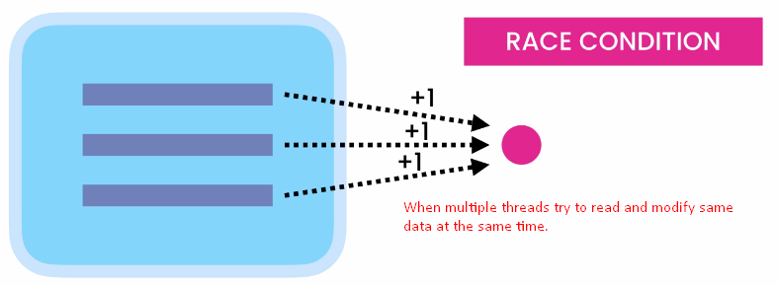
5. **Visibility Issue**:
   1. 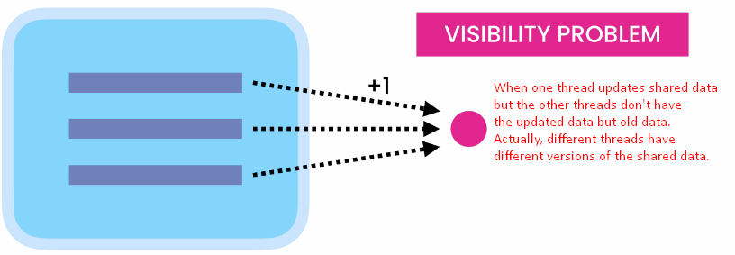
6. 